**Submission Guidelines for the Grasping System**

**Use the template below to submit your proposal, the file should be submitted in .pdf format**

# Functional Description

## Descprition of Design

In this section, describe how your design can perform all the requirements. Describe it in few sentences by answering this question:

1. Standby:
   * How do you ensure that your GS does not move during this mode but it is able to receive commands? (R1)
2. Pick:

* How does your GS pick all the items in the possible positions? (R2)
* How does your GS pick all the different items? (R2)
* How does your GS receive “pick” command? (R3)
* How can it detect if an object is picked? (R4)

1. Place:
   * How does your GS release the item? (R5, R6, R7)
   * How do you check if the item falls before “release” command is received? (R8)

You can attach images if it can help you describing your design.

**Minimum content requirement: Text response to each of the above questions**

## Functional Analysis

In this section, describe your logic and/or analysis for your grasping system design by answering this following question:

1. How do you ensure that the picked item won’t be damaged?
2. Is it possible to grab multiple item?
3. What is the estimated total mass? (present it in a table consist of each components)

**Minimum content requirement: Text response to each of the above questions**

# System layout

In this section, provide a diagram(s) identifying all the physical components of your grasping system and how it is connected to each other, power, and signal. You can represent the mechanical part in an exploded view and the electrical part in a wiring diagram. (R11, R12)

# Design drawings

In this section, include engineering-style drawing showing your solution’s physical configuration. An accurate dimension is required. (R9, R10)

# Software Description

In this section, provide a high level flow chart of sequence of operations. You don’t need to specify the exact code, just provide a general function. Your software description should be complete that a programmer could implement the algorithm. Present your software’s control flow description using an Activity/Control Flow Diagram, also known as a Flowchart. Table 1 shows the description of each shape. Figure 1 shows the example of a flowchart. (R13)

|  |  |
| --- | --- |
| **Shape** | **Description** |
|  | A rounded rectangle or oval represents beginning or ending of a program or sub-process. |
|  | A rectangle represents a process or operation that changes value or state of a variable |
|  | A diamond represents the conditional operation that determines which process to be executed. |
|  | An arrow represents the flow of the operations. |

Table 1. Flowchart Explanation

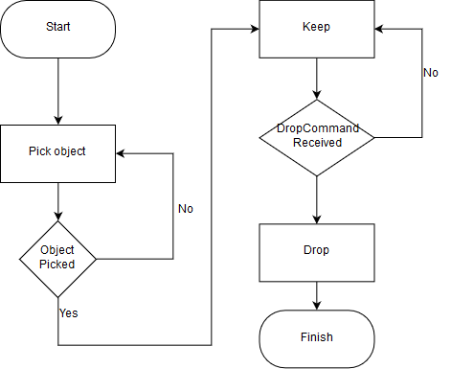

Figure 1. Example of Flowchart

**Minimum content requirement: A flowchart that shows your software description. No text is required. Used the standard symbol**

# Estimated Cost

In this section, describe the estimated cost for your design

# Maintenance projection

In this section, describe the maintenance projection for your design.